**AWS Directory Service**



AWS Directory Service for Microsoft Active Directory, also known as AWS Managed Microsoft Active Directory (AD), enables your directory-aware workloads and AWS resources to use managed Active Directory (AD) in AWS. [AWS Managed Microsoft AD](https://aws.amazon.com/directoryservice/active-directory/) is built on actual Microsoft AD and does not require you to synchronize or replicate data from your existing Active Directory to the cloud. You can use the standard AD administration tools and take advantage of the built-in AD features, such as Group Policy and single sign-on. With AWS Managed Microsoft AD, you can easily join [Amazon EC2](https://aws.amazon.com/ec2/) and [Amazon RDS for SQL Server](https://aws.amazon.com/rds/sqlserver/) instances to your domain, and use [AWS End User Computing](https://aws.amazon.com/products/end-user-computing/) (EUC) services, such as [Amazon WorkSpaces](https://aws.amazon.com/workspaces/), with AD users and groups.

***Benefits of Active Directory***

1. Easy migration of om-premises workloads
2. Use actual Microsoft Active Directory (AD)
3. Share a single directory for cloud workloads
4. Centrally manage application access and devices in AWS
5. Simplify administration with a managed service

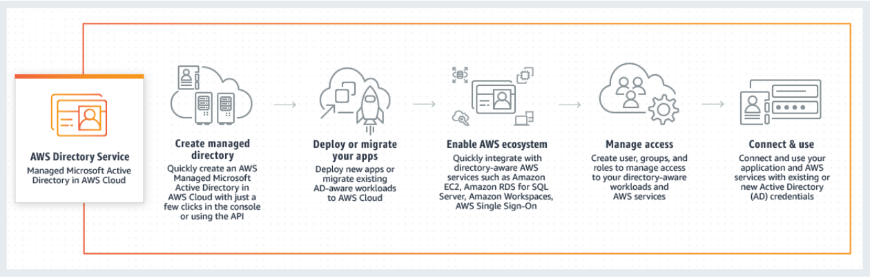

***Use cases of Active Directory***

* Provide your on-premises AD users quick access to AWS
* Leverage integrations with Amazon RDS and Amazon FSx
* Enable single sign-on experience for AWS end user computing services
* Grant your on-premises AD users single-click access to cloud business applications

**Step-wise process to configure AD**

***Step – 1*** Login procedure

Login to your AWS Management Console.

Set up your Region from the top right-hand corner.

Under the Security, Identity, and Compliance section, click on ‘Directory Services’.

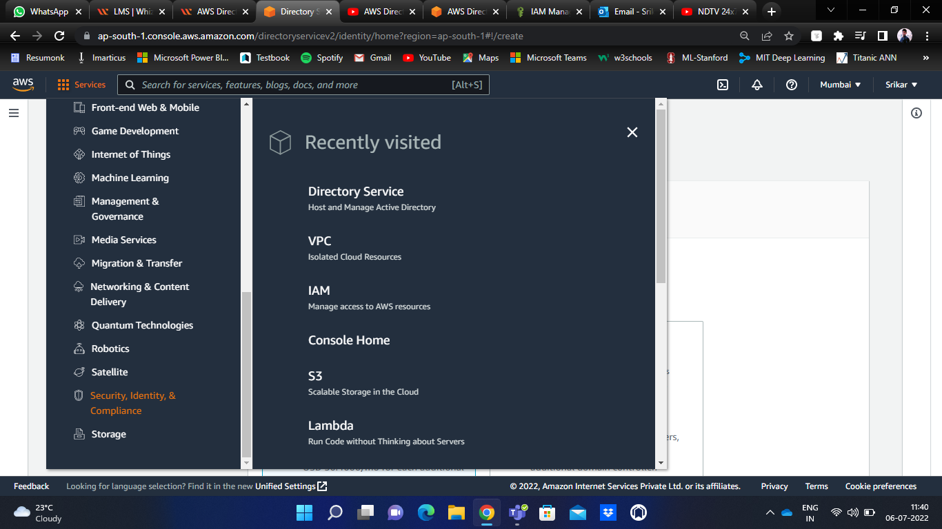

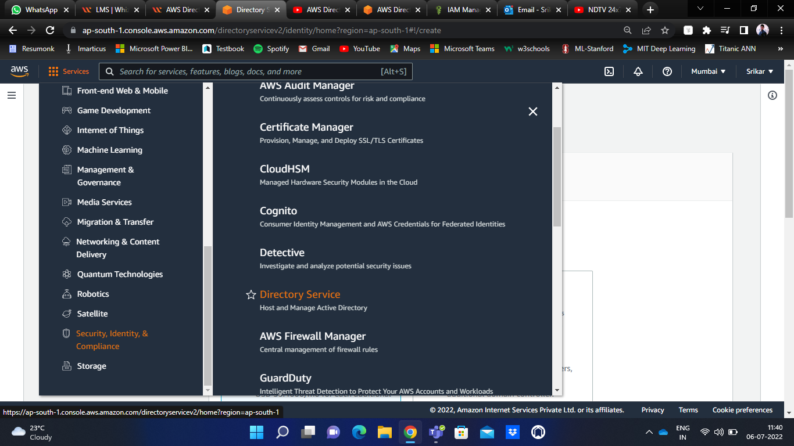

***Step – 2*** Setting-up the directory

After clicking on the Directory Service, you will be navigated to the AD page.

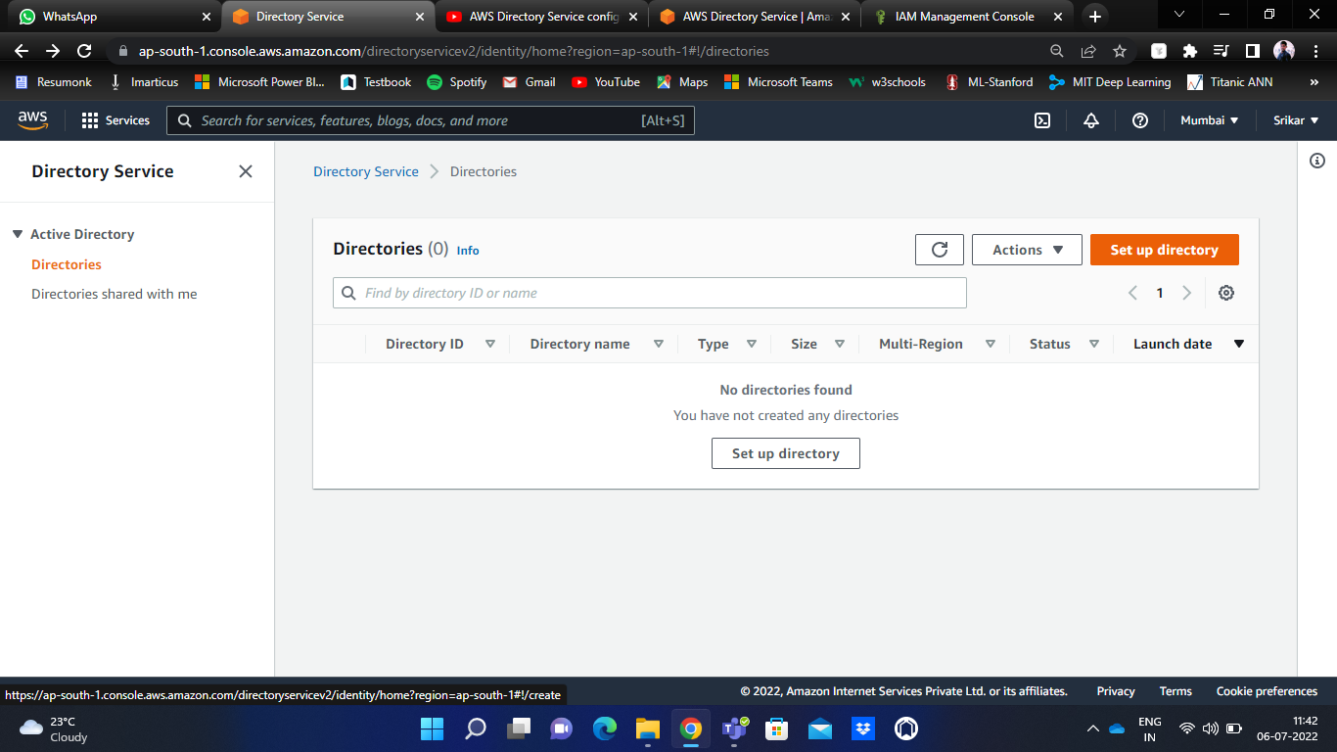

Click on ‘Set up directory’.

Select the directory type as ‘AWS Managed Microsoft AD’ and click on next.

In the directory information, you will find Edition. Set the ‘Standard Edition’.

Give a Directory DNS name of your choice.

Lastly, you have to provide a password and confirm the same.

Click on next.

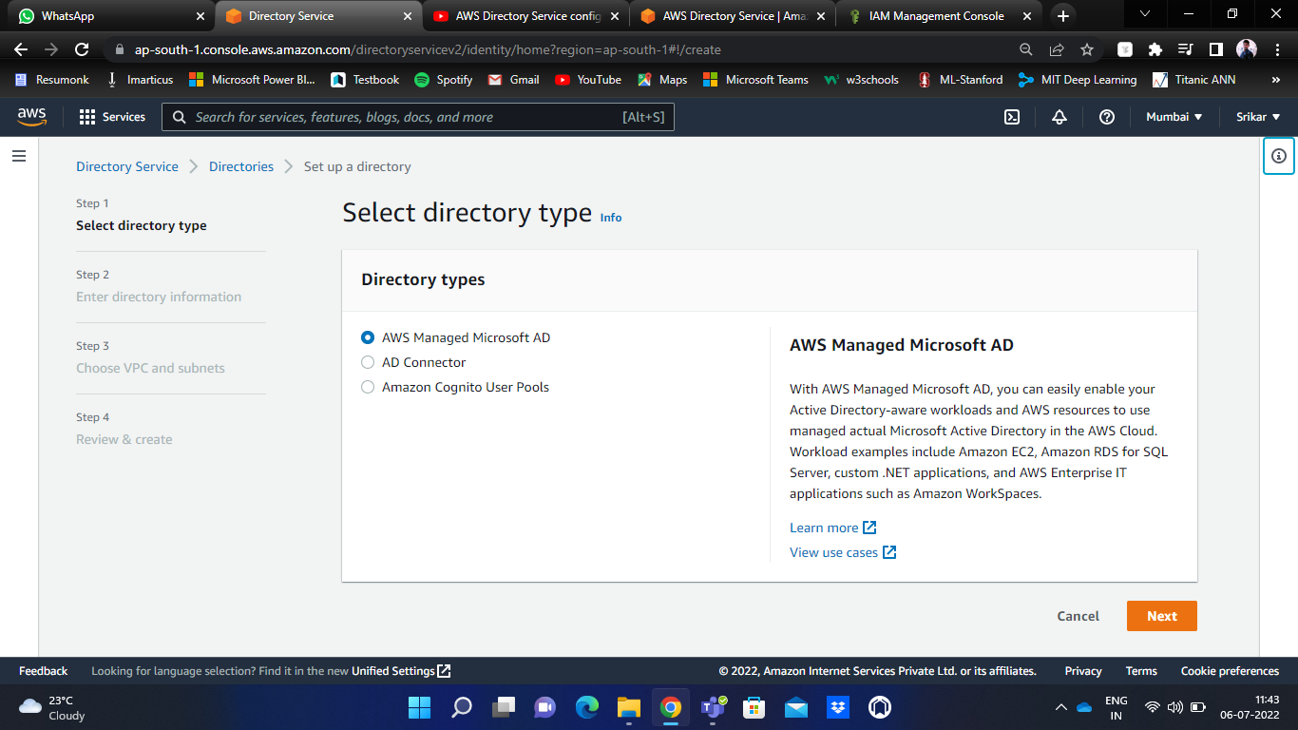

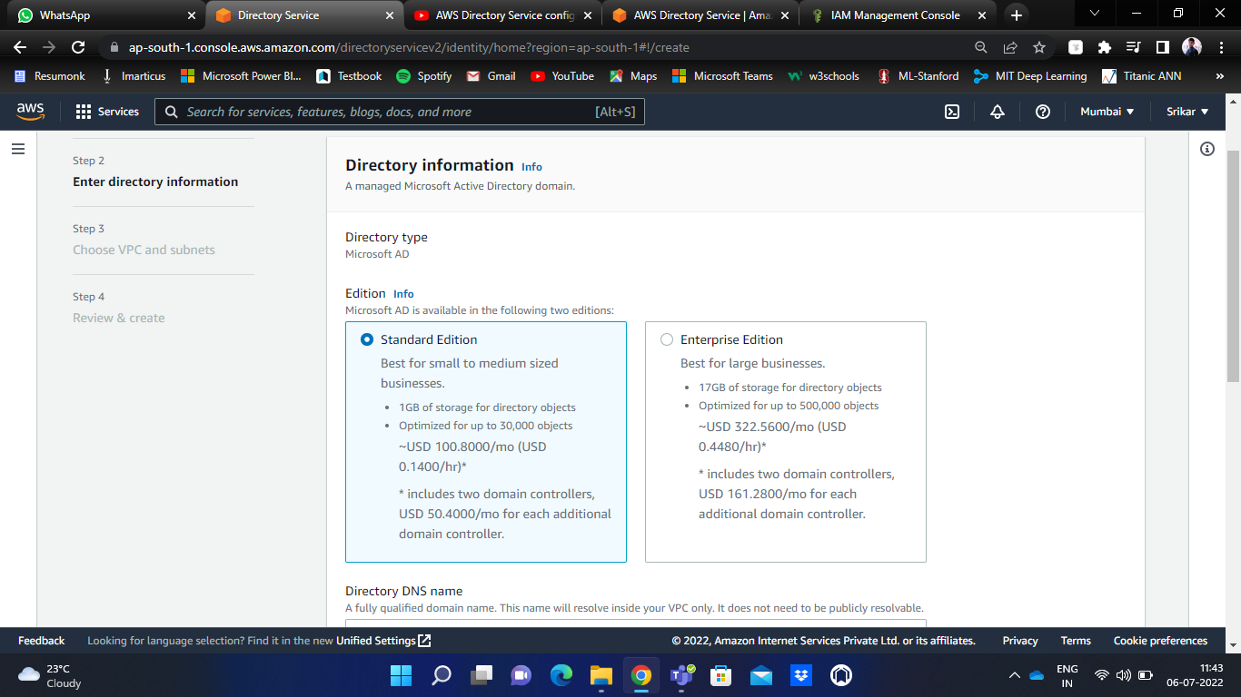

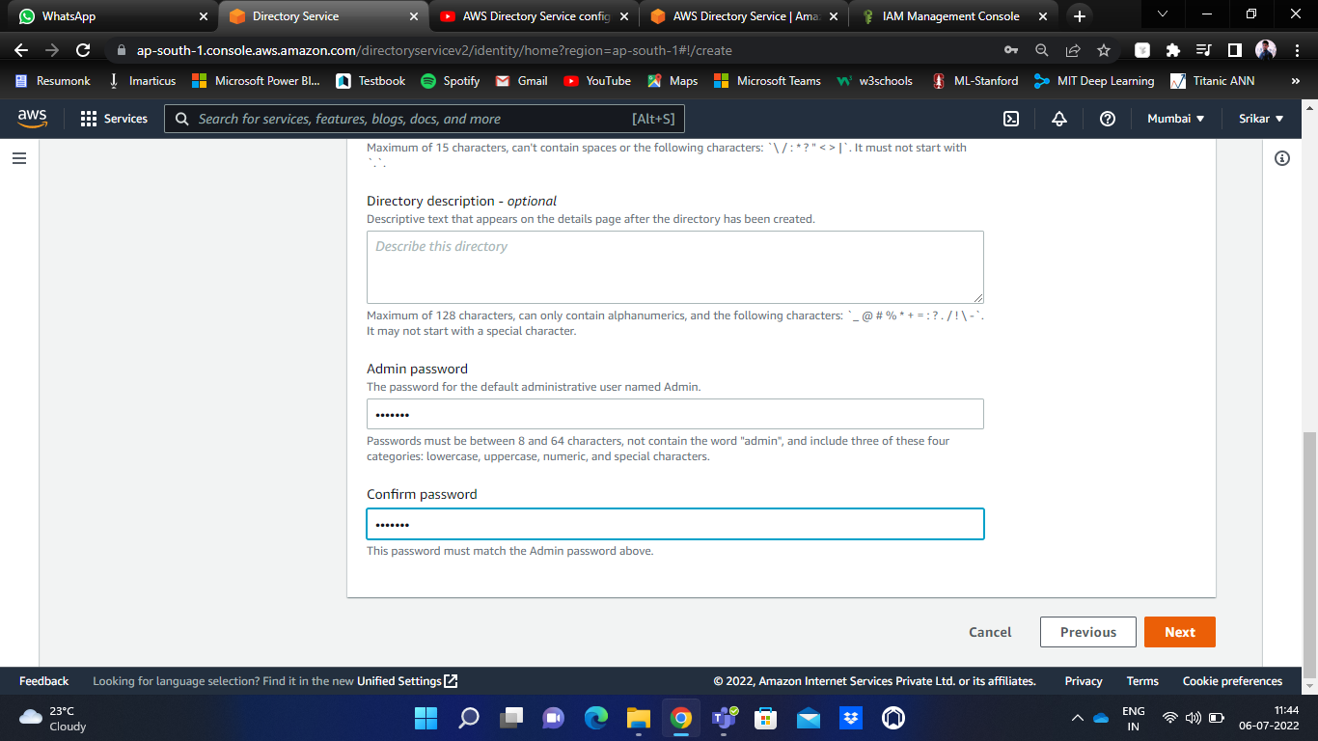

***Step – 3*** VPC settings

Select a VPC option. You have to select two VPC subnets, one each from a different availability zone.

Ex: Subnet-1 is from ap-south-1a, and Subnet-2 is from ap-south-1b.

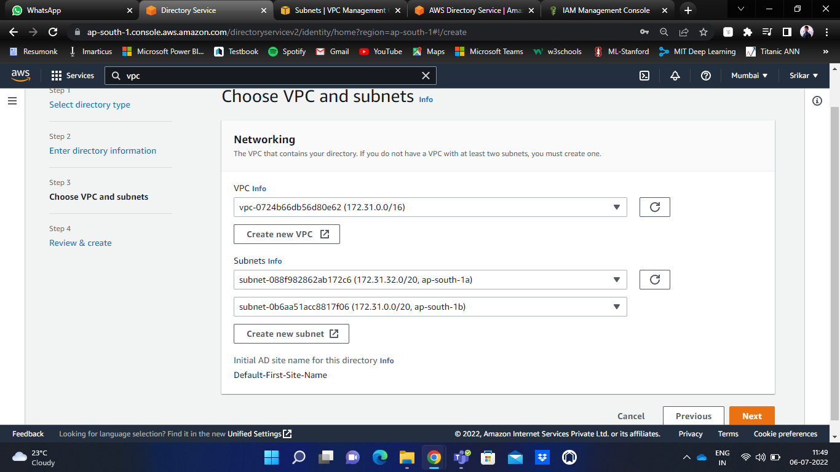

Click on next.

Now, you can review all your AD details along with its pricing details here.

Finally, click on ‘Create directory’.

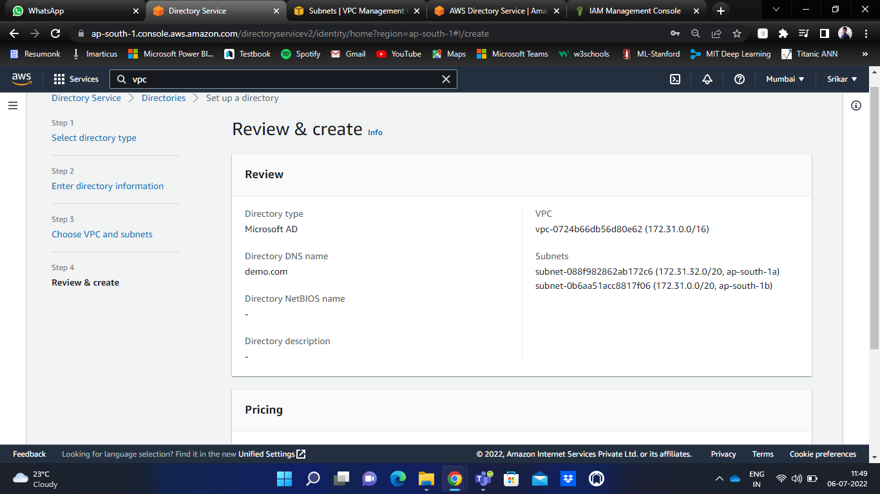

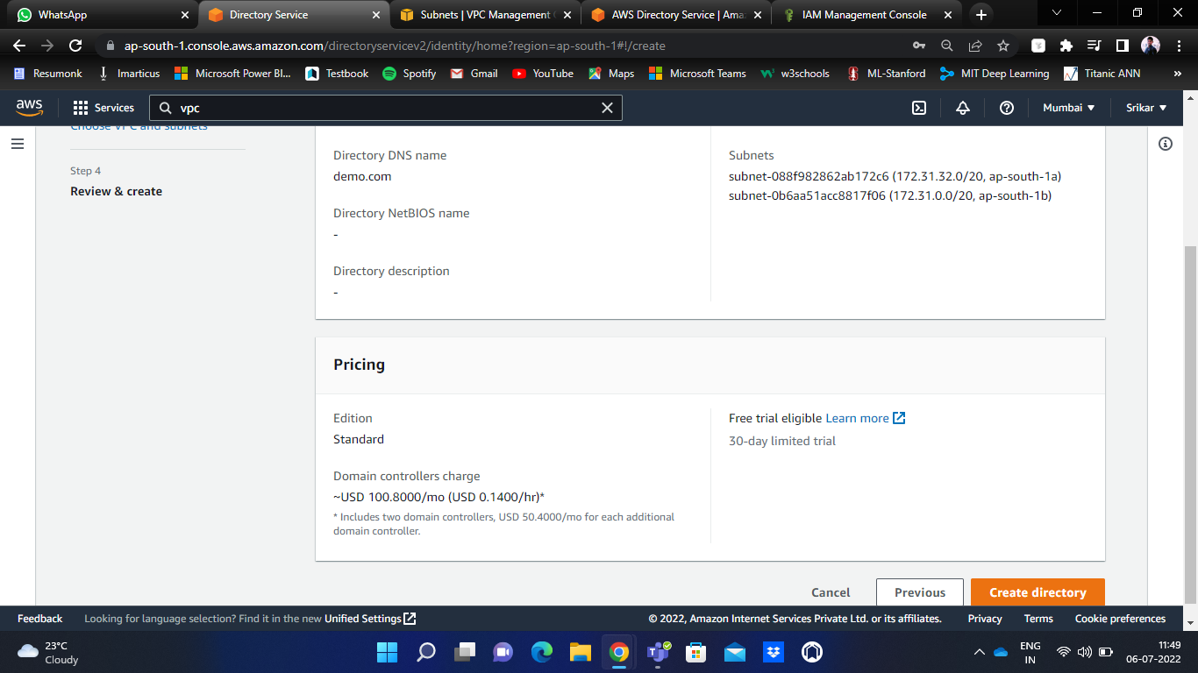

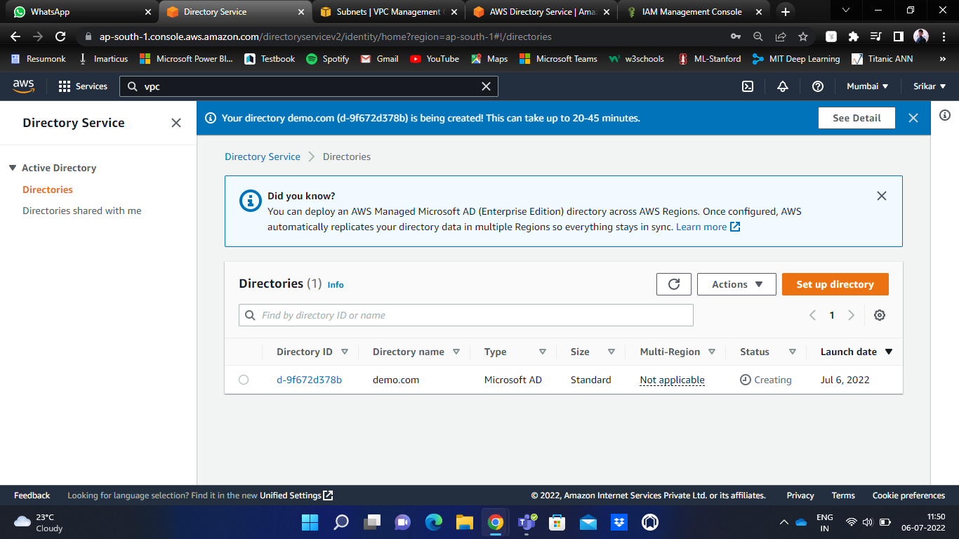

It may take up to 45 minutes to create an active directory.

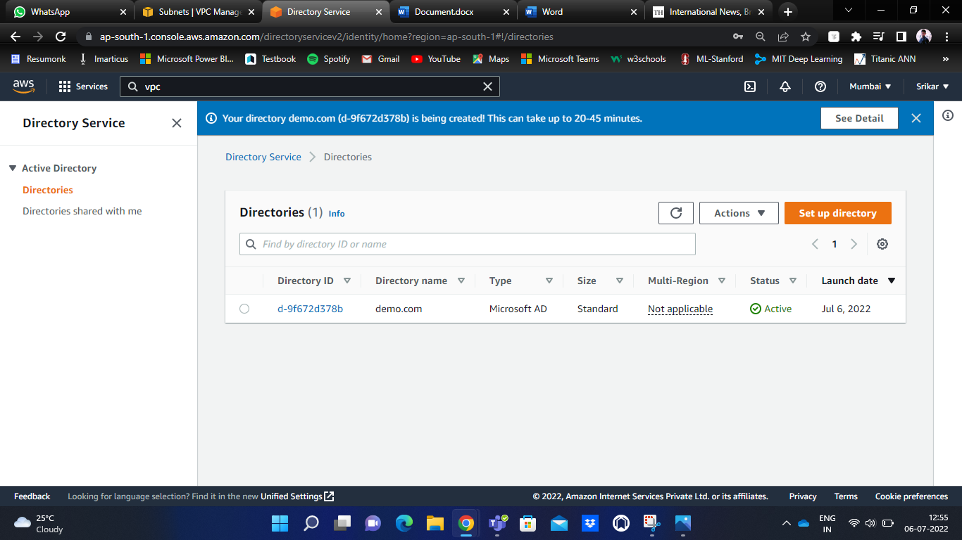

After the successful creation of the directory, the ‘Active’ status will be shown.

Now, the directory is completely set up and ready to use.

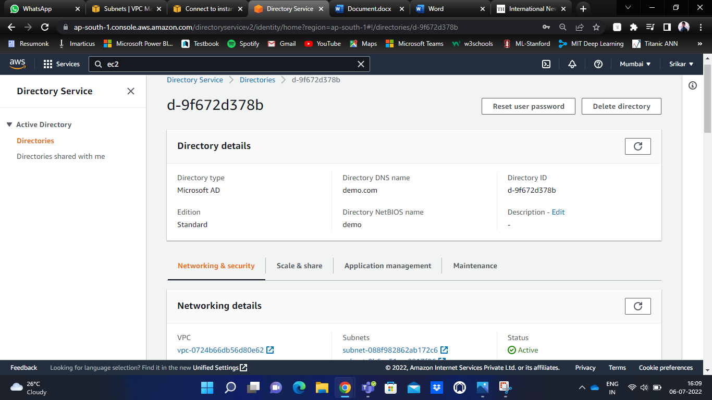

You can notice the directory details here.

To check the networking details, click on ‘Networking & Security’.

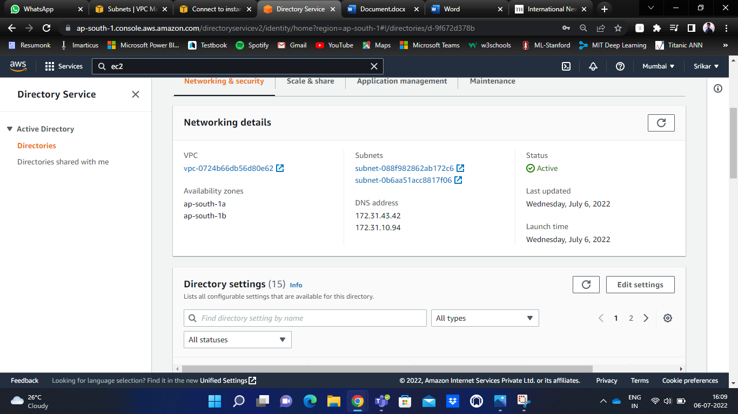

You can view VPC details, subnet details, DNS addresses, Availability zones, etc.

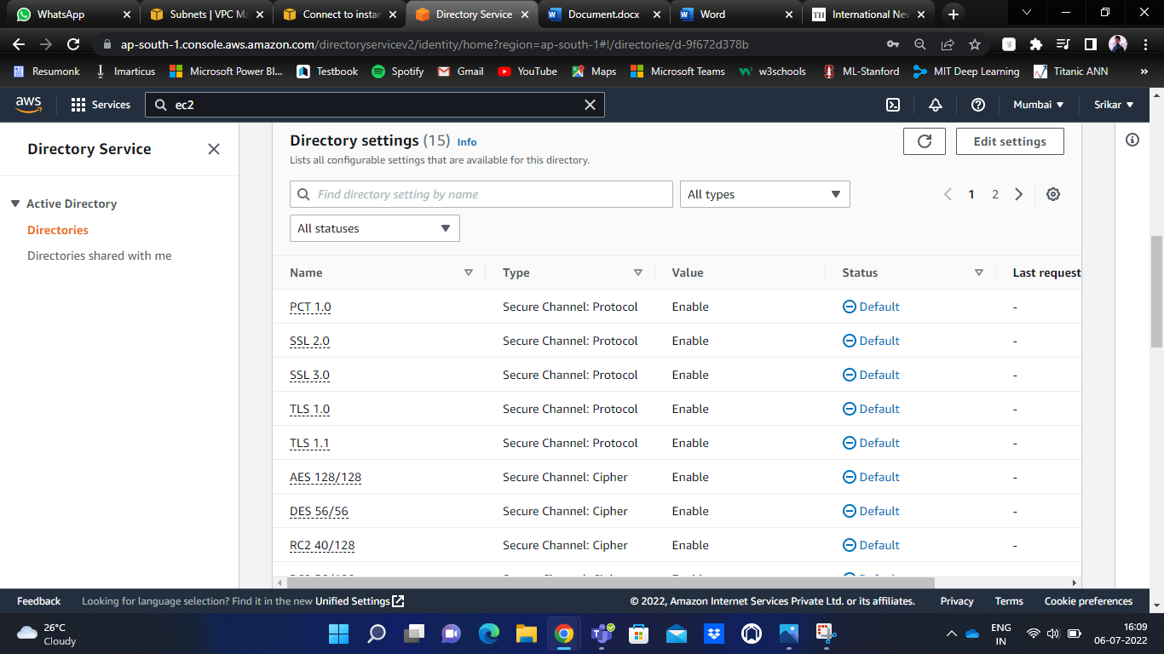

All the directory settings like SSL, TLS, etc., are enabled by default.

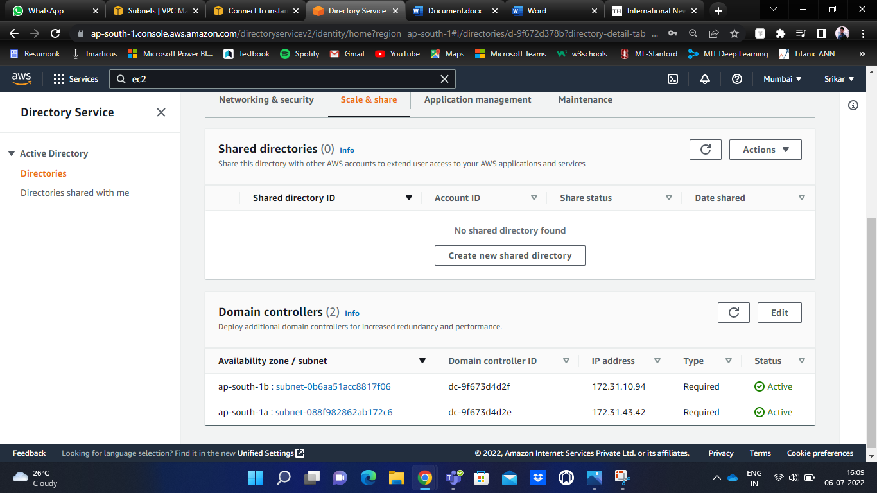

Under ‘Scale & Share’, there is an option ‘Create new shared directory’.

By clicking that, we can add multiple IDs to our Microsoft AD, to whom we wish to share our directory.

You can also see the list of applications and services That can be enabled in the customer account for users to use this shared library.

